**Digital Compass with Micro: Bit**

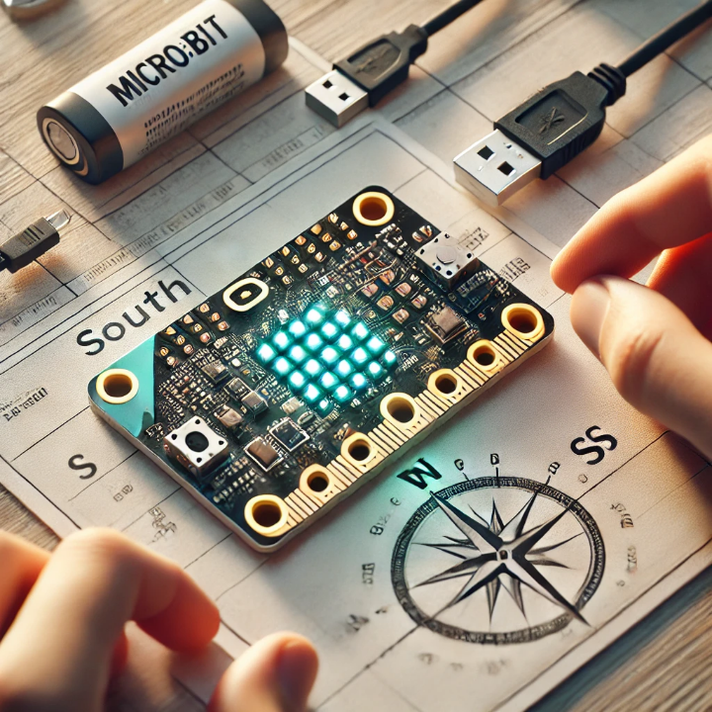

**Overview**

The Digital Compass Project transforms the Micro: bit into a pocket-sized compass that displays cardinal directions (North, East, South, West) on its LED matrix. It leverages the Micro: bit’s built-in magnetometer to detect the Earth's magnetic field and provide real-time orientation feedback.

**Goals Addressed**

**• Goal 1. Logical Systems**

* Program the Micro: bit to using Blocks from Microsoft MakeCode editor to track the number of steps

**• Goal 15. Product Prototyping**

* Build a functional prototype for steps tracking

**Steps to create a digital compass**

* **Step 1**

Go to [MakeCode](https://makecode.microbit.org/) website start a new project and Name it

“Digital Compass” Click OK then this window will appear:

* **Step 2**

Remove On start block right click on this block and choose “Delete Block”, And from click on and name the variable “bearing” click OK and choose drag it inside [forever] block like this:

* **Step 3**

from choose drag it inside here:

To be like this :

* 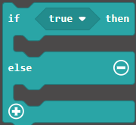**Step 4**

From choose drag it below the [set] block like this:

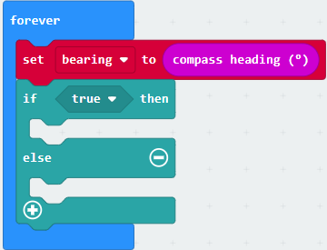

* **Step 5**

From choose drag it inside the “true” like this:

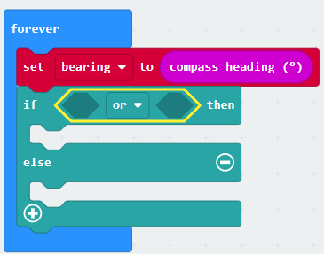

Also from choose 2 of but the first one in the right side and in

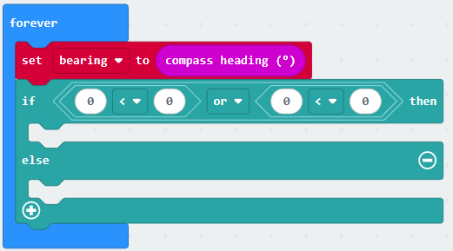 [or] block and the other one in the left side like this:



 Chage the comparison sign of the left side to be larger than from here

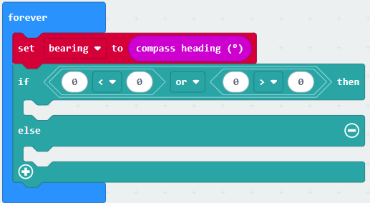 Choose to be like this:

Now go to choose 2 of drag them here :

To be like this:

click the sign in the [if] block 2 times, the else if will appear and the blocks will be

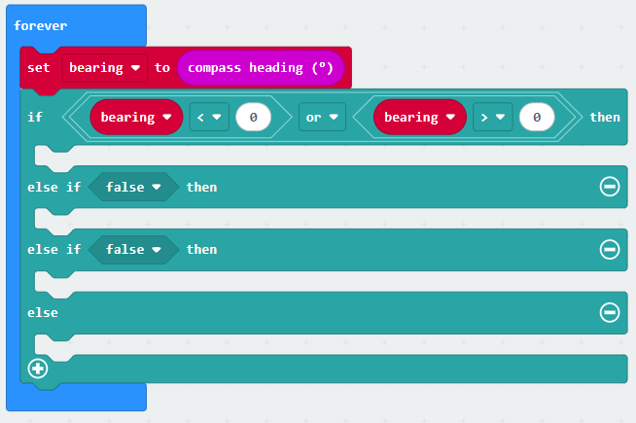like this :

* **Step 6**

Now select the [or] Block, a yellow boundary will appear like this :



Now click CTRL + C to Copy it

Then paste it 2 times by clicking on CTRL + V

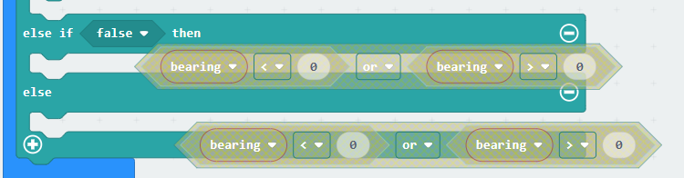These 2 copies will appear:

Drag them here:

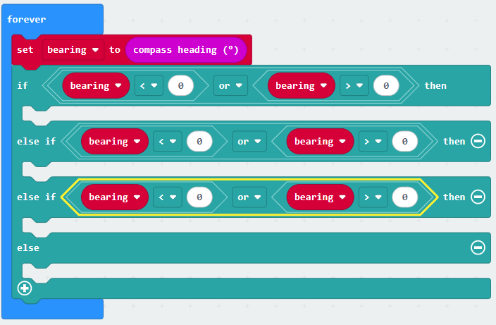 To be like this:

* **Step 7**

From choose 4 of and place them here

To be like this:

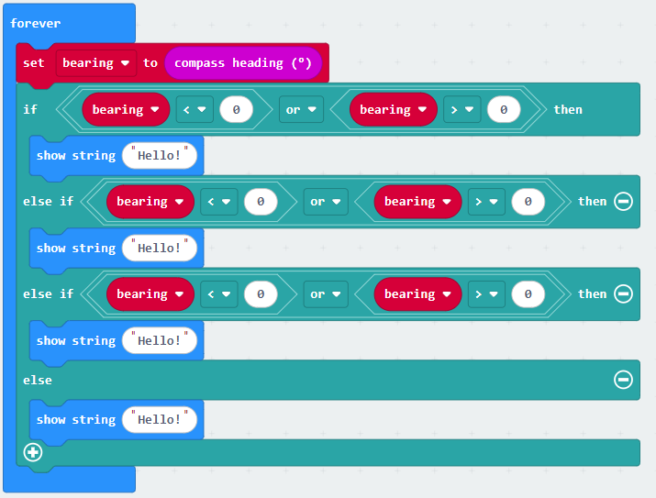

Now change the “Hello” by clicking on “Hello” then you can change it by the cardinal

directions (North, East, South, West):

Change the first one by: N

Change the second one by: E

Change the third one by: S

Change the forth one by: W

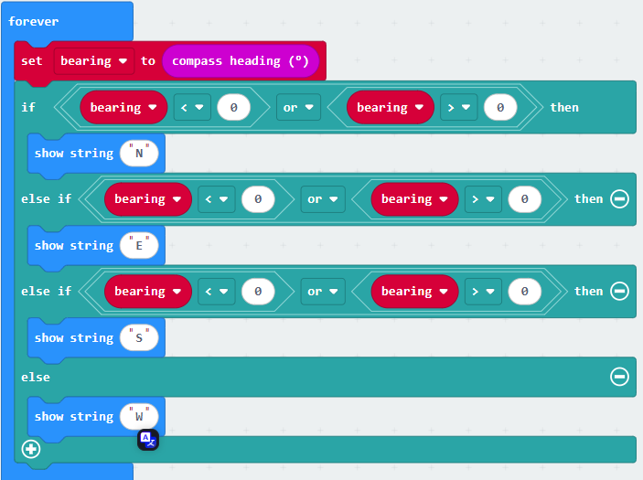Like this:

Now we need to set the bearing ranges of cardinal directions

45(North, East, South, West):

For the North range is less than 45 or more than 315

For the East range is less than 135 or more than 45

For the South range is less than 225 or more than 135

For the West the range is less than 315 or more than 225

It should be like this:

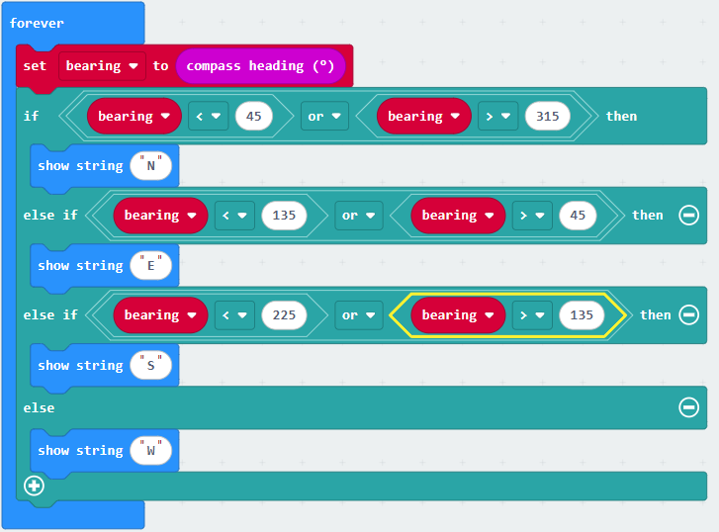

We have reached the final step on this project, Change those signs to “Equal to”

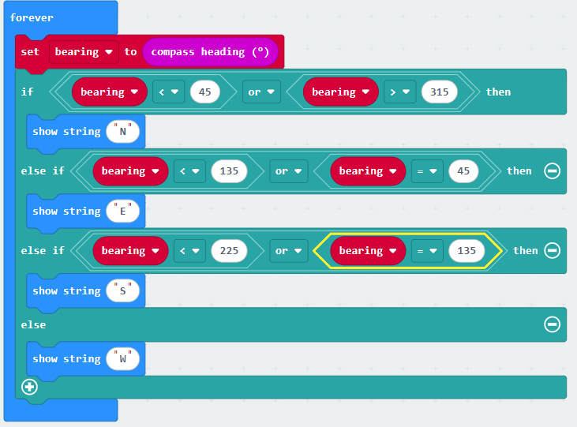To be like this:

Now plug the micro bit to the computer and press

**Great work now you have finished this project, you have a digital compass in your hand enjoy <3**